A179-Asia-Harappa-Bajaur Valley, Female figurine, 2800-2600 BCE.

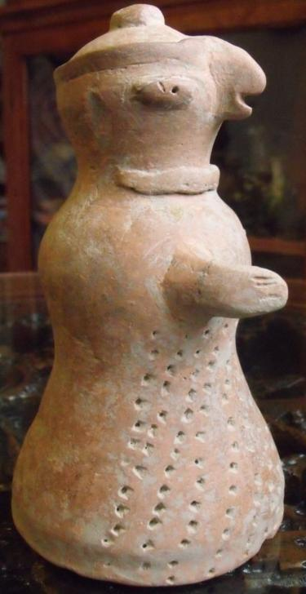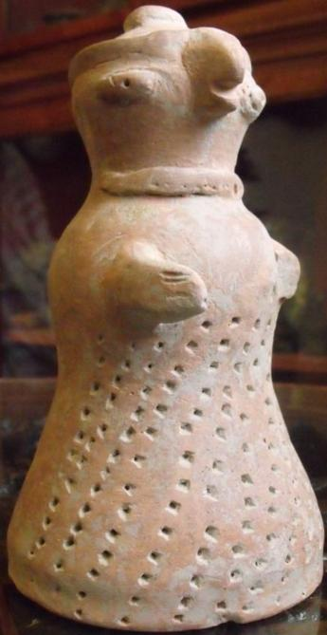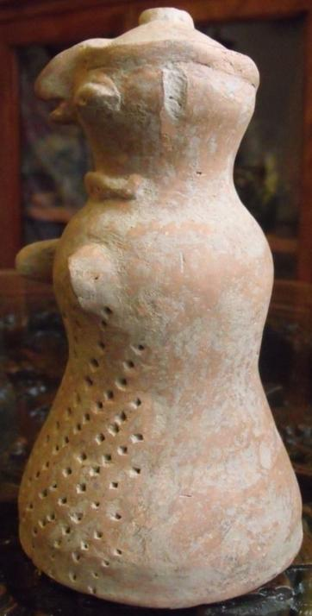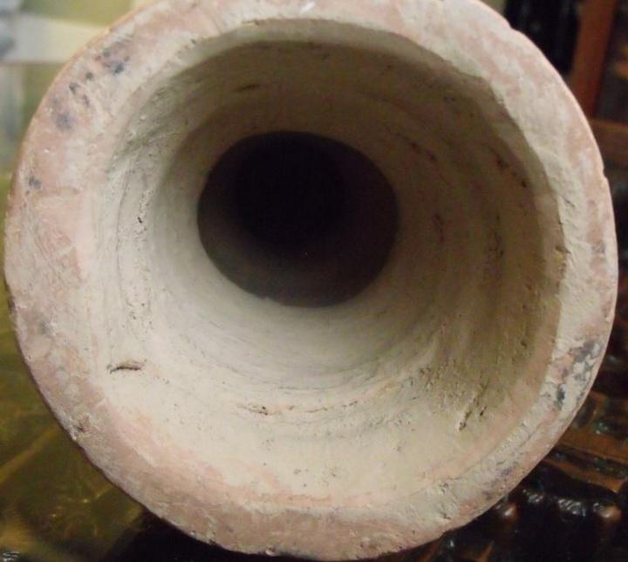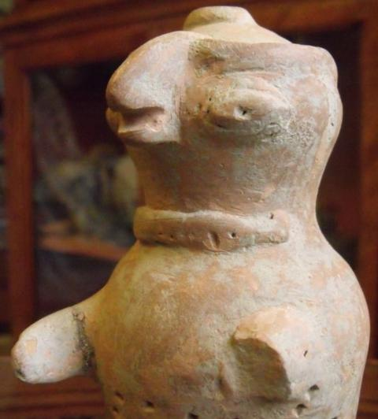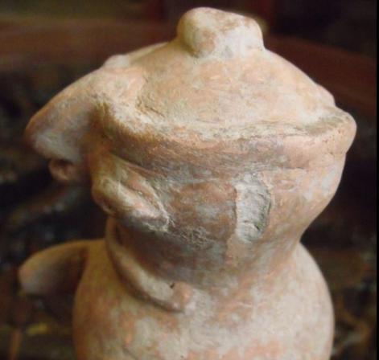

Figs. 1-6. Harappa-Bajaur Valley, Female figurine, 2800-2600 BCE. Accession Number: A181

Case no.: 3

Formal Label: Harappa-Bajaur Valley, Female figurine, 2800-2600 BCE.

**Display Description:**

The cylindrical body is punctated with 1/32 in circular depressions that imply a fabric design below the chest possibly suggesting folds in a skirt. Dots in a necklace suggest precious stones or pearls and may indicate elevated social status. Lack of prominent breasts suggest that this figurine portrays an older female priestess of an avian goddess engaged in assisting cultic worshippers in successful childbearing who are themselves nubile. The hairdressing with a semi-circular gathering and surmounted with a promininent bob also suggests a stylized priestly accoutrement.

The left lower arm and ears are missing. The cylinder is hollow with an everted base. It is well known that among the cultures extending from the Tibetan Plateau to western India and Pakistan through Afghanistan to Turkey, the practice of excarnation or allowing carrion birds such as vultures to ingest the bodies of the deceased and so imbibe their spirit was extensively practiced. In this context the curve of the votive cultic offrand suggests that the deity involved was associated with the local carrion birds, which in the case of Harappa would have been the gyphon vulture. The bell-shaped hollow body is illustrative of the flowing skirts of Bajaur Valley female cultic figurines.

A female figure such as this one, being made of terracotta, materially originates with the Earth and has been identified as a Mother Goddess by most scholars. This figure embodies three aspects that are not mutually exclusive. First, it may be a votive image of a human birth-giving mother (perhaps as a specific votary object to assist the women of a family in their birth-giving rôles). Secondly, it may be a general archetypal symbol for harvested crops or yields of animal husbandry, both products of Earth. An association with animals may allude to an ability to command animals as the queen beasts, tame and wild. Thirdly, it may be the object of a fertility cult, specifically focused on the need to supply a family with children and then later with young adults, who could help manage the family’s farming and herding. As an element of the family’s security, this archetypal rôle is practiced by one billion women in the developing world today.

Cultural Affiliation: Harappa

Medium: terracotta

Dimensions: H 22 cm

Weight: 833 grams,

Condition: original

Provenance: part of an old collection

**Discussion:**

An archetypal mother in Indus civilization appears to be projected as a local female divinity. The cult of local female-worship, coupled with a fertility cult, seems to have been deep-rooted and wide-spread in Neolithic India, since female figurines have been recovered from nearly every excavated site. This pervasiveness suggests that women played a central rôle in their *family’s* *local economy* and *religion* and that the society that supported such a rôle for women was *locally egalitarian*.

However, this localism existed in tandem with a non-local, male-dominated administration of centralized city-states. This included fairly extensive town-planning, maintenance of weights and measures and the production of a variety of unique stamp seals that were ostensibly part of the business identification of a wealthy, male merchant class that engaged in extensive trading throughout the subcontinent and the Near East.

This hollow bell-shaped terracotta figurine is probably from Bajaur valley (area of 600 sq. miles), a hilly area located northwest of Malakand at the border between Pakistan and India, in the sphere of influence of the early Harappan Civilization during the so called Regionalization Era, 2800-2600 BCE (Kenoyer 1998: 39-45).

**References:**

Atre, Shughangana. 1987. *The Archetypal Mother: A Systematic Approach to Harappan Religion*. Pune: Ravish Publishers.

Bailey, Donald M. 1997. “Terracotta Figurines of Eastern Gujarat”. In Ian Freestone and David Gamester, eds., *Pottery in the Making: Ceramic Traditions*. Washington, D.C.: Smithsonian Institution Press.

Bhattacharyya, N. N. 1999. *The Indian Mother Goddess*. New Delhi: Manohar.

**AP:** Est 6,500 USD (2016; Barakat Gallery, 405 North Rodeo Drive, Beverly Hills, California-90210); Pd 400 USD Australian Collection, 2016). Extremely rare.

Weight 833 grams, height 22 cm. REFERENCES

**Kenoyer, Jonathan Mark. 1998. *Ancient cities of the Indus Valley Civilization.* Karachi, Pakistan: American Institute of Pakistan Studies, Oxford University Press.**

Beautiful  large and very rare **Ancient Indus Valley Terracotta MOTHER  GODDESS**,  17.5 cm height, 9.5 cm diameter at base In an excavated condition. Has had a red-brown paint over the majority of its surface, only remnants left. Ex-U.K. collection. From the earlier end of the ancient Indus Valley civilization around 2300**B.C**.E. Indus Valley was only discovered for the west in 1921 and excavations didn't begin till 1926 and never on the scale of Ancient Egypt even though they existed at the same point in time, only a few thousand km's apart. Indus have been found to have been the earliest users of polychrome paints, surpassing the Mesopotamians who were thought to be the earliest, they have now been found to be the earliest practitioners of dentistry, were advanced in town planning, sewerage and water.  Certificate Of Authenticity supplied.

# Order details

Printer friendly page

## Sales order

Sold by [dave1000.123](http://myworld.ebay.com/dave1000.123) ( [3402](http://feedback.ebay.com/ws/eBayISAPI.dll?ViewFeedback&userid=dave1000.123) )

+ Show additional actions

### Delivery package 1 of 1

Estimated delivery Friday, May 20, 2016 -Wednesday, Jun 1, 2016

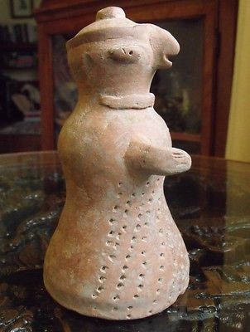

#### [RARE ANCIENT INDUS VALLEY MOTHER GODDESS ca.2300 BC. Harappan Culture](http://www.ebay.com/itm/311506251137)

|  |  |
| --- | --- |
| **Item price** | AUD 600.00 |
| **Quantity** | 1 |
| **Item number** | 311506251137 |
| **Shipping service** | AusPost Registered Post International Parcel |

[Contact seller](http://contact.ebay.com/ws/eBayISAPI.dll?FindAnswers&frm=3998&iid=311506251137&redirect=0&requested=dave1000.123)

[Return item](http://return.ebay.com/ws/eBayISAPI.dll?ResolveReturn&eventName=viewSelectedItem&TransactionId=677721181021&ItemId=311506251137)

## Shipping address

Ralph J Coffman Jr

149 Atlantic Ave

Swampscott MA 01907-2427

United States

## Order total

|  |  |
| --- | --- |
| **Subtotal** | AUD 600.00 |
| **Shipping** | Free |

**Total**

AUD 600.00

[View PayPal transaction](http://payments.ebay.com/ws/eBayISAPI.dll?UnifiedCheckoutSummaryRedirect2PP&itemid=311506251137&transId=677721181021&buyerorseller=0)

Order placed on

Tuesday, May 10, 2016

Payment method

PayPal

Payment date

Tuesday, May 10, 2016